Agile and Scrum Foundations
Set 1: Online Grocery Delivery Application
Product Vision:
For busy household shoppers needing quick access to daily essentials, the FreshCart Grocery Application is a mobile-first app that delivers fresh groceries to their doorstep. Unlike traditional grocery stores, FreshCart offers live delivery tracking, inventory updates, and fast checkout.
Scrum Roles & Anti-Patterns:
- Product Owner: Manages the product backlog. Anti-pattern: Proxy PO who has no decision authority and delays sprint decisions.
- Scrum Master: Facilitates Scrum events. Anti-pattern: Command-and-control manager who assigns tasks directly to developers.
- Developers: Builds the working software increment. Anti-pattern: Technical silos where developers only work on isolated tasks.
User Stories & Backlog:
Epic | ID | User Story Description
EPIC-1: Browse | FCG-101 | As a shopper, I want to browse products by category so I can locate items.
EPIC-1: Browse | FCG-102 | As a shopper, I want a search bar so I can find items quickly.
EPIC-1: Browse | FCG-103 | As a shopper, I want dietary filters (Vegan, Organic) so I see relevant products.
EPIC-1: Browse | FCG-104 | As a shopper, I want to see promotional discounts on items to save money.
EPIC-2: Checkout | FCG-105 | As a user, I want to add/remove items in the cart so I can modify my order.
EPIC-2: Checkout | FCG-106 | As a user, I want to apply coupon codes at checkout to get discounts.
EPIC-2: Checkout | FCG-107 | As a user, I want to choose a delivery time slot so I receive items conveniently.
EPIC-2: Checkout | FCG-108 | As a user, I want to pay securely online so I can complete my order.
EPIC-3: Tracking | FCG-109 | As a customer, I want to track the driver live on a map so I know arrival time.
EPIC-3: Tracking | FCG-110 | As a customer, I want order status notifications so I stay updated.
EPIC-3: Tracking | FCG-111 | As a customer, I want driver contact details so I can give delivery directions.
EPIC-3: Tracking | FCG-112 | As a customer, I want to rate the delivery experience so I can share feedback.

INVEST Review & Story Rewriting:
- FCG-108 (Full Payment System) was too large. Split into FCG-108 (Payment Processing) and FCG-108B (Invoice Generation).
- FCG-109 (Live Tracking) was vague. Rewritten to specify map location updates every 30 seconds.
Acceptance Criteria (Given / When / Then):
1. FCG-106 (Valid Coupon): Given user has $50 items in cart, When they enter valid code 'FRESH10', Then total drops by $10.
2. FCG-106 (Invalid Coupon - Negative): Given user is at checkout, When they enter invalid code 'EXPIRED', Then an error message displays.
3. FCG-102 (Auto-Suggest): Given user types 'Milk', When 2 letters are entered, Then suggestions show within 300ms.
4. FCG-109 (Live Tracking): Given order status is 'Out for Delivery', When tracking tab is opened, Then driver location refreshes every 30s.
5. FCG-105 (Cart Update): Given cart has 2 apples, When user clicks '+', Then quantity updates to 3.
Estimation & Prioritization (MoSCoW & Story Points):
Reference Story Chosen: FCG-105 (Cart Update) = 2 Story Points.
ID | Title | MoSCoW Priority | Points
FCG-101 | Category Browsing | Must Have | 3
FCG-102 | Search Auto-suggest | Must Have | 5
FCG-103 | Dietary Filter | Should Have | 2
FCG-104 | Promotions Display | Should Have | 3
FCG-105 | Cart Adjustment (Ref) | Must Have | 2
FCG-106 | Coupon Checkout | Must Have | 3
FCG-107 | Delivery Slot | Must Have | 3
FCG-108 | Secure Payment | Must Have | 5
FCG-109 | Live Tracking | Should Have | 5
FCG-110 | Push Notifications | Should Have | 3
FCG-111 | Contact Driver | Could Have | 2
FCG-112 | Rate & Review | Could Have | 2

JIRA Board & Quality Criteria:

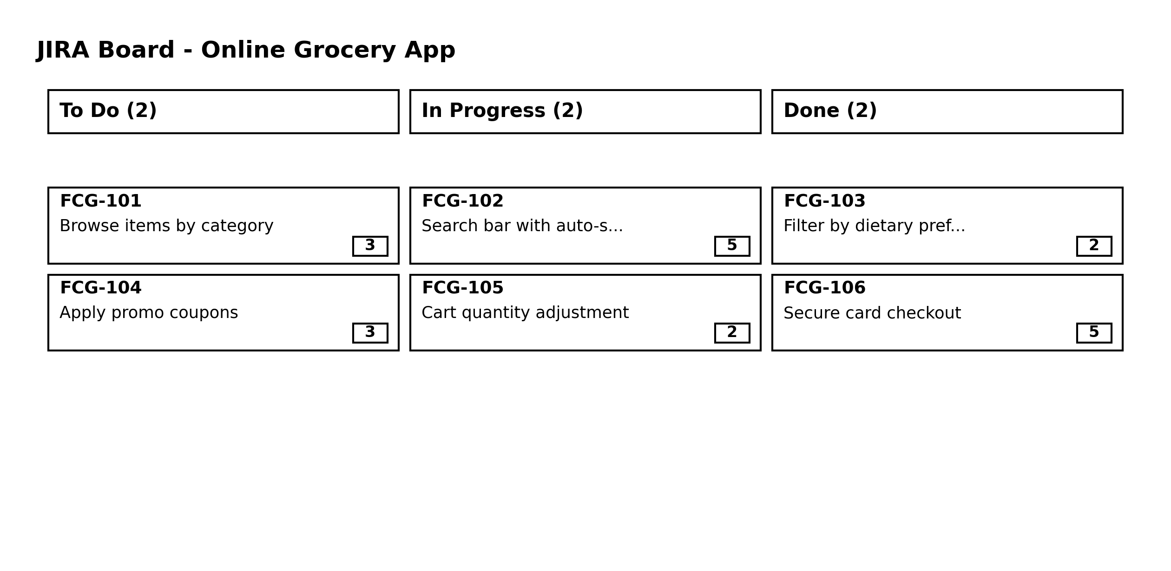

- Definition of Ready (DoR): Story in 'As a / I want / So that' format, clear acceptance criteria, and estimated points.
- Definition of Done (DoD): Code completed, unit tests passed (80%+ coverage), QA tested, and approved by Product Owner.
Set 2: Insurance Claims Portal
Product Vision:
For policyholders filing insurance claims, the InsurCare Claims Portal is a self-service web app that enables online claim registration, document upload, and settlement tracking. It shortens turnaround time from weeks to days.
Waterfall vs. Agile Comparison:
Waterfall relies on rigid, sequential phases where changes late in the project cause major delays. Insurance regulations and user needs change frequently. Agile allows releasing a core working MVP (Claim Submission) in 4 weeks and iteratively adding feature improvements based on real feedback.
User Stories & Backlog:
Epic | ID | User Story Description
EPIC-1: Registration | ICP-201 | As a policyholder, I want to initiate a claim using my policy number.
EPIC-1: Registration | ICP-202 | As a claimant, I want to select the loss type and incident date.
EPIC-1: Registration | ICP-203 | As a claimant, I want to enter a incident description.
EPIC-2: Documents | ICP-204 | As a claimant, I want to upload medical bills and receipts (PDF/JPG).
EPIC-2: Documents | ICP-205 | As a claimant, I want validation error messages if my uploaded file is too large.
EPIC-2: Documents | ICP-206 | As an assessor, I want to view uploaded documents to verify the claim.
EPIC-3: Tracking | ICP-207 | As a claimant, I want a visual status tracker to see claim progress.
EPIC-3: Tracking | ICP-208 | As a claimant, I want to see adjuster contact details.
EPIC-3: Tracking | ICP-209 | As a claimant, I want to read notes left by the assessor.
EPIC-4: Settlement | ICP-210 | As a claimant, I want SMS alerts when status changes.
EPIC-4: Settlement | ICP-211 | As a claimant, I want an email breakdown of payout amount.
EPIC-4: Settlement | ICP-212 | As a claimant, I want to enter bank details for direct payout.
EPIC-4: Settlement | ICP-213 | As a manager, I want payout audit logs for compliance.

INVEST Review & Vertical Splitting:
A large story 'ICP-200: Full Claim System' was split vertically into small slices: Slice 1 (ICP-201: Form input & saving), Slice 2 (ICP-204: File upload), and Slice 3 (ICP-205: Validation feedback).
Acceptance Criteria:
1. ICP-201 (Valid Policy): Given valid policy 'POL-123', When user clicks 'Verify', Then holder details auto-populate.
2. ICP-201 (Invalid Policy - Negative): Given invalid policy 'POL-000', When user clicks 'Verify', Then error message displays and submission blocks.
Backlog Estimation & Outlier Discussion:
Total Backlog Size: 41 Story Points.
Outlier Discussion (ICP-212: Bank Details Input): Developer A estimated 2 points (simple form UI), while Developer B estimated 8 points (strict banking security & encryption requirements). The team discussed and agreed on 5 points.
JIRA Board Screenshot & Scrum Overview:

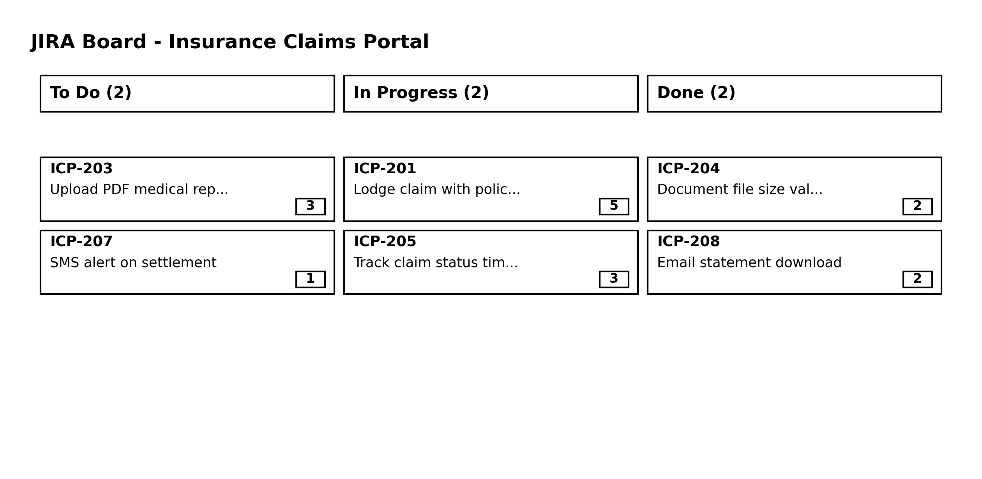

- Roles: Product Owner, Scrum Master, Developers.
- Events: Sprint Planning, Daily Scrum, Sprint Review, Retrospective.
- Artifacts: Product Backlog, Sprint Backlog, Increment.
Set 3: Hospital Appointment Booking Application
Product Vision:
For patients booking doctor appointments, the CareTime Hospital App is a mobile application for searching doctors, scheduling slots, receiving reminders, and managing appointments quickly.
Stakeholder Mapping Matrix:
Stakeholder | Scrum Role | Responsibilities
Hospital Chief Medical Officer | Product Owner | Defines feature requirements and clinical priorities.
Agile Coach / Project Lead | Scrum Master | Facilitates Scrum framework and removes blockers.
Mobile Developers & Testers | Developer | Builds, tests, and deploys mobile app features.
Patients & Visitors | Customer | End users booking doctor appointments.
Hospital Desk Staff | Customer / End User | Manages daily doctor schedules on-site.

User Stories & Backlog:
Epic | ID | User Story Description
EPIC-1: Booking | HCA-301 | As a patient, I want to search doctors by specialty so I can find the right doctor.
EPIC-1: Booking | HCA-302 | As a patient, I want to view open time slots so I can select a convenient time.
EPIC-1: Booking | HCA-303 | As a patient, I want to pay online so my appointment is confirmed.
EPIC-1: Booking | HCA-304 | As a patient, I want a QR confirmation ticket to show at reception.
EPIC-2: Reschedule | HCA-305 | As a patient, I want to reschedule my slot up to 2 hours prior to the time.
EPIC-2: Reschedule | HCA-306 | As a patient, I want to cancel my booking and request a refund.
EPIC-3: Reminders | HCA-307 | As a patient, I want SMS notifications before my appointment.
EPIC-3: Reminders | HCA-308 | As a patient, I want to add appointments to my phone calendar.
EPIC-4: Doctor Schedule | HCA-309 | As a doctor, I want to set weekly available working hours.
EPIC-4: Doctor Schedule | HCA-310 | As a doctor, I want to block out leave slots so patients cannot book.
EPIC-4: Doctor Schedule | HCA-311 | As a receptionist, I want to view master schedules to handle walk-ins.
EPIC-4: Doctor Schedule | HCA-312 | As a doctor, I want to view daily patient lists to prepare for visits.

INVEST Review Refinements:
- HCA-303: Decoupled payment processing from calendar syncing to make it testable and independent.
- HCA-306: Clarified cancellation rules (>24 hours = 100% refund, <24 hours = 50% refund) to make it estimable.
Acceptance Criteria (Booking & Slot Conflict):
1. HCA-302 (Normal Booking): Given open slot at 10 AM, When patient selects and pays, Then slot status becomes 'Booked' and ticket generates.
2. HCA-302 (Slot Conflict - Negative): Given two users select 10 AM slot, When User A completes payment first, Then User B receives error alert 'Slot no longer available'.
Prioritization & Story Points vs. Hours:
- Story Points: Story Points measure relative effort, complexity, and uncertainty. They do not change based on who completes the work.
- Ideal Hours: Hours measure absolute elapsed time, which varies depending on developer experience level.
JIRA Board & DoR/DoD Checklists:

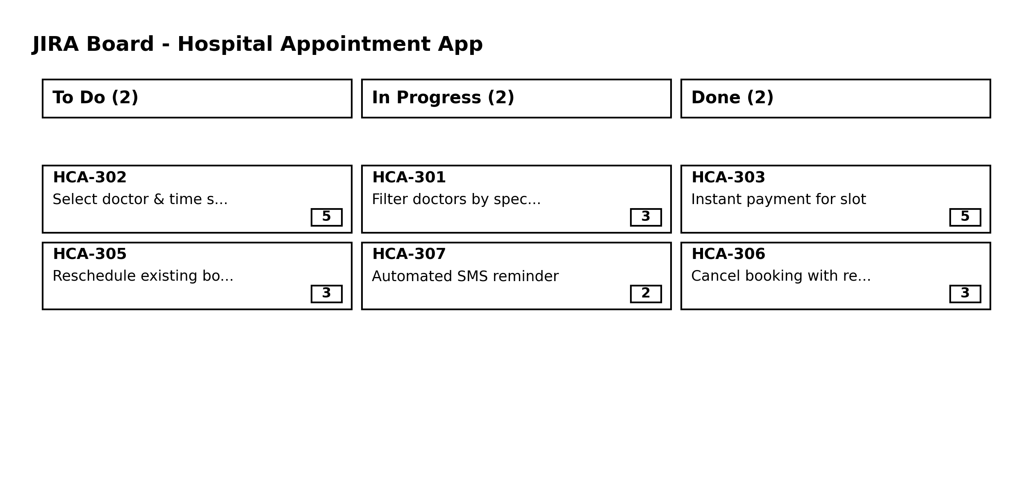

Definition of Ready (DoR) Checklist (6 Items):
- 1. User story template standard format used.
- 2. Given/When/Then acceptance criteria defined.
- 3. Estimated using Planning Poker points.
- 4. UI wireframes attached.
- 5. Technical dependencies identified.
- 6. Small enough to complete within 1 sprint.
Definition of Done (DoD) Checklist (6 Items):
- 1. Code peer-reviewed by senior developer.
- 2. Unit tests passing with 80%+ coverage.
- 3. QA verified on iOS and Android.
- 4. User and API documentation updated.
- 5. Merged into main branch.
- 6. Accepted by Product Owner.

